Economics: Factors of Production

Goal: The Factors of Production
- What is economics?

- Fill in the chart: FACTORS OF PRODUCTION

FACTOR OF PRODUCTION  (Cell) | DEFINITION | EXAMPLES
Capital

Entrepreneurship | Someone who risks time, money and has idea to start business
Labor

Land (Natural Resources) | Renewable:  Nonrenewable:

Objective: Scarcity and Choices
- Define scarcity:

- Why does scarcity exist?

- Because of scarcity, producers must make ___________.
- What happens to production costs and prices if resources are scarce or expensive?

- Define consumer:

- Define producer:

- Name two ways that consumers are affected by scarcity:

- What is the difference between a wage and a salary?

Objective: Trade-offs and Opportunity Costs
- Read the following scenarios and indicate whether the situation is a trade off or an opportunity cost by checking the appropriate box.
Scenario | Opportunity Cost | Trade-Off
James decides to go to college after high school and therefore loses out on earning money from a low paying job.
Tiffany chooses to go to cheerleading practice this afternoon so she cannot spend her time shopping with her friends.
Kelly decides to ride her bike to work instead of driving to cut down on pollution and to save money on gas.
Nikki decides to buy herself Christmas presents so she doesn’t have enough money to buy anyone else a gift!

- What is an incentive?

- Fill in the chart by providing a definition, an example, and an illustration of each of the following types of costs:
Type of Cost | Definition | Example | Illustration
Fixed
Variable

Objective: Specialization, Division of Labor, Consumption

- Define specialization:

- Define division of labor:

- Fill in the chart: ADVANTAGES and DISADVANTAGES of SPECIALIZATION and DIVISION OF LABOR
ADVANATAGES | DISADVANTAGES
- Fill in examples for the following types of workers.
Type of Worker | Give 1 Example
White Collar – Skilled Worker
Blue Collar – Skilled Worker
White Collar – Unskilled Worker
Blue Collar – Unskilled Worker

- How would you increase your human capital?

- What is mass production? What type of worker would work in a factory using mass production?

Objective: Impact of Investment on Human Capital, Production, Natural Resources

- What is the difference between output and input?

Objective: Different Economic Systems

Adam Smith, author of the Wealth of Nations, is credited as being the Father of Capitalism. He argued that businesses and individuals should be able to make economic decisions without government involvement. This is called Laissez-Faire economics, which means “to-let-be,” in French (because the government is “hands-off” with business activity). Smith argued that if government gets involved with the market, it will limit productivity and limit wealth in a nation. He said that if an individual does what is best for them and tries to start a business to make a profit, they will also help society. If you want to make a profit you have to do something that meets the needs or wants of other people in your society so your product will actually sell. Smith called this idea The Invisible Hand Theory and said that the market economy should operate without government interference and should let individual self-interests (doing what makes you happy and rich) meet the needs of society like an “invisible hand”.

Use the paragraph to answer the following questions.

- What is Adam Smith’s Invisible Hand Theory?

- What are the advantages and disadvantages to government involvement in business?
Advantages | Disadvantages

- What are two advantages of a competitive market for consumers?

Economic Systems

- Fill in the chart: CHARACTERISTIC OF ECONOMIC SYSTEMS

ECONOMIC SYSTEM | CHARACTERISTICS  (Who answers the 3 basic economic questions?; How does each system answer the 3 questions?)
TRADITIONAL

COMMAND ECONOMIES
(Communism)

MARKET ECONOMY
(Capitalism)
(Free Enterprise)

MIXED ECONOMIES
(Socialism)

Objective: Free Market Enterprise, Private Ownership, and Individual Initiative

- What does it mean if a company is productive? How would a company increase productivity?

- What is the difference between a patent and a copyright?

- What economic concept allows an individual to own their own house, car, business, etc.?

- What is voluntary Exchange?

Objective: The Circular Flow

- Fill in the chart (along the arrows) to show the flow of products, the factors of production, and money: THE CIRCULAR FLOW

Product Market:

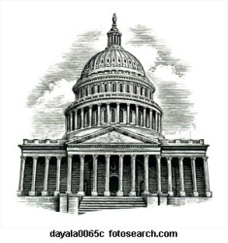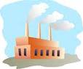

Factor Market:

- The chart above shows the Circular Flow of Economics in a mixed economy because the government plays a role. If we took the government sector out of the above chart, what type of economic system would the chart portray?

- If Danielle works at McDonalds, is she participating in the Factor Market or the Product Market? Why?

- If Mark buys some French fries from Danielle, is he participating in the Factor Market or the Product Market? Why?

Objective: Supply, Demand, and Prices

- Label the chart below: (Be sure to include: supply curve, demand curve, equilibrium point, equilibrium price, equilibrium quantity, and the price and quantity axis’s.)

Draw an increase in Demand at all prices.

Draw an increase in Supply at all prices.

- What influence do complimentary goods have on Demand?

Price of a complimentary good goes up: demand will _______________
Price of a complimentary good goes down: demand will _______________

- What influence do substitute goods have on Demand?

Price of a substitute good goes up: demand will _____________
Price of a substitute good goes down: demand will _____________

Objective: Shortages, Surpluses, and Prices

- Fill in the chart:

TERM | DEFINITION | WHAT SHOULD HAPPEN TO PRICE TO RETURN TO EQUILIBRIUM?
Surplus

Shortage

- When supply and demand are equal, we have an _______________________ price.

Objective 8.06: Types of Markets

- How does a monopoly hurt the consumer?

- If the following companies merged, what type of merger would it be?

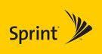 __________________

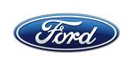 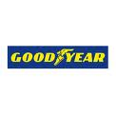 __________________

- What type of merger occurred when Yamaha (which makes sound equipment) bought a motor bike company?

Objective 8:07: Business Organizations

TYPE OF BUSINESS | DEFINITION | ADVANTAGES | DISADVANTAGES
Sole Proprietorship

Partnerships

Corporations

Franchise

- Corporation owners are called __________________________. They buy/sell stocks in the ____________________________.
- What is the SEC and what do they do? (Not the Southeastern Conference!)

- Why do labor unions form? What do they do for workers?

- What is collective bargaining?

Objective: Investment Decisions

- What is a commercial bank? What do they do? Give two examples of commercial banks.

- What is a Time Deposit and how does it differ from a Demand Deposit?

- What is a credit union? Give an example.

- What is the function of the Federal Deposit Insurance Corporation (FDIC)?

- What is a mutual fund?

Economics: Factors influencing the US Economy

Objective: Business Cycle and Economic Indicators

- Label the different stages of the business cycle:

A: ______________
B: ______________
D 1) __________:
G Economic decline for
D A over 6 months
P 2)__________:
C Economic decline for a
B prolonged time period
C: _____________
D: _____________
Time

- List 3 major leading economic indicators.

Objective: Impact of Movement of Human Capital and Resources in Economy

- Color and label each of the following on the map. Once labeling the map, define each region.
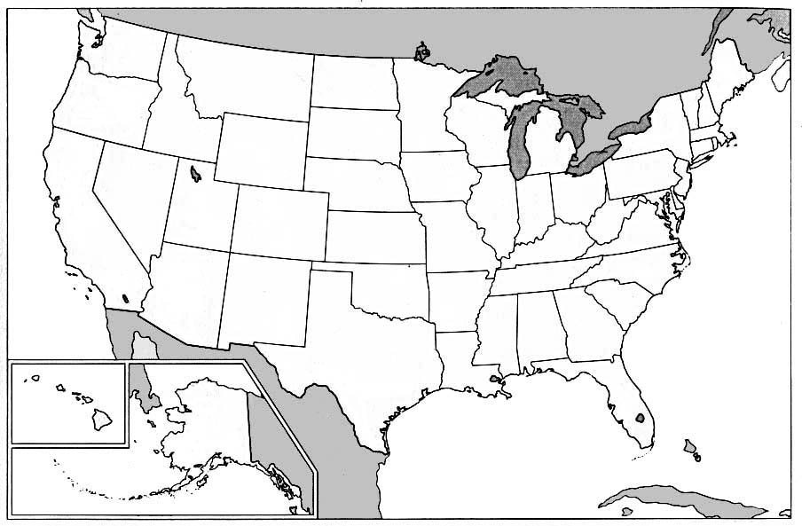

Sunbelt:

Rustbelt:

Silicon Valley:
- Why are more people moving into the Research Triangle Park (RTP)?

Objective: Impact of US Economy on International Trade & Global Developments

One of the best ways for a country to ensure that they have a good economy is to make sure that they maintain a favorable balance of trade. This means that they should sell more goods (exports) than they are buying from other countries (imports). An unfavorable balance of trade is when a country buys more stuff (imports) than they sell (exports). Imagine if you spent more money than you made…what would your bank account look like? Bad, huh?! The same thing goes for an entire country – if we spend more money as a country (buying imports from other countries) and do not bring any money in by selling our own products (exports) our national “bank account” looks terrible! That’s why we call it an unfavorable balance of trade. As responsible Americans we should try to buy American made goods, not foreign goods, that way our money stays in the United States. If we do buy foreign goods, the United States government sometimes adds an extra tax, so at least we make some money. A tax on a foreign good is called a protective tariff.

Answer the following questions on the above reading:

- Why should a country sell more goods (exports) than they buy (imports)?

- How does the US government help protect businesses from foreign competition?

- Define these three groups that monitor national trade:

NAFTA (North American Free Trade Agreement) –

WTO (World Trade Organization) –

EU (European Union) -

Objective: Domestic and International Trade Interdependent

- What is free trade and how does it benefit countries?

- How does the United Nations work to increase trade among member countries?

- What role does the International Monetary Fund (IMF) play in the global economy?

Objective: Effects of Fiscal and Monetary Policy

- Define monetary policy:

fiscal policy:

- Define the following types of taxes:
  - Personal Income Tax:

  - Excise Tax:

  - Regressive Tax:

  - Progressive Tax:

  - Proportional Tax:

  - Sales Tax:

- What is “loose money”? What is “tight money”?

- How can The Fed loosen or tighten the money supply? (In terms of the Discount Rate and the Reserve Requirement)

Objective: Influence of Environmental Factors, Economic Conditions, and Policy

- Fill in the chart: FACTORS AFFECTING THE ECONOMY

FACTOR | HOW ECONOMY IS AFFECTED
Natural disasters

Economic development | Bear Market:  Bull Market:
Decisions of government leaders

Goal: Positions on Issues in Constitutional Democracy

Goal: Personal and Civic Responsibilities

- Give examples of civic responsibilities.

- Give examples of civic duties:

Goal: Issues of Diversity

Use the following terms to fill in the blanks in this reading on American Diversity:

Melting Pot; Bias; Cultures; Religion; Diversity; Celebrate; Physical Appearance

Americans should respect _____________. We should not have _____, or treat people differently, based on gender, __________, disability, lifestyle, or ____________________. We should treat all people the same, regardless of our differences. Not only should we respect these differences, but we should _____________ them! As we learn more about other __________ and people that are different from ourselves, we grow as individuals and as a nation! After all, American culture is unique because we are a _______________; citizens from all over the world have migrated here so our culture has bits and pieces of many global traditions.

Goal: Characteristics of Effective Citizenship

True or False:

An effective citizen should do all of the following:
  - Own property and have their right to own property protected. _____
  - Vote only in important elections. _____
  - Pay a portion of their taxes. _____
  - Respect the rights of others. _____
  - Participate in community service activities only when forced by government officials. _____
  - Be knowledgeable about the history of their communities. ______
  - Be informed. _____

